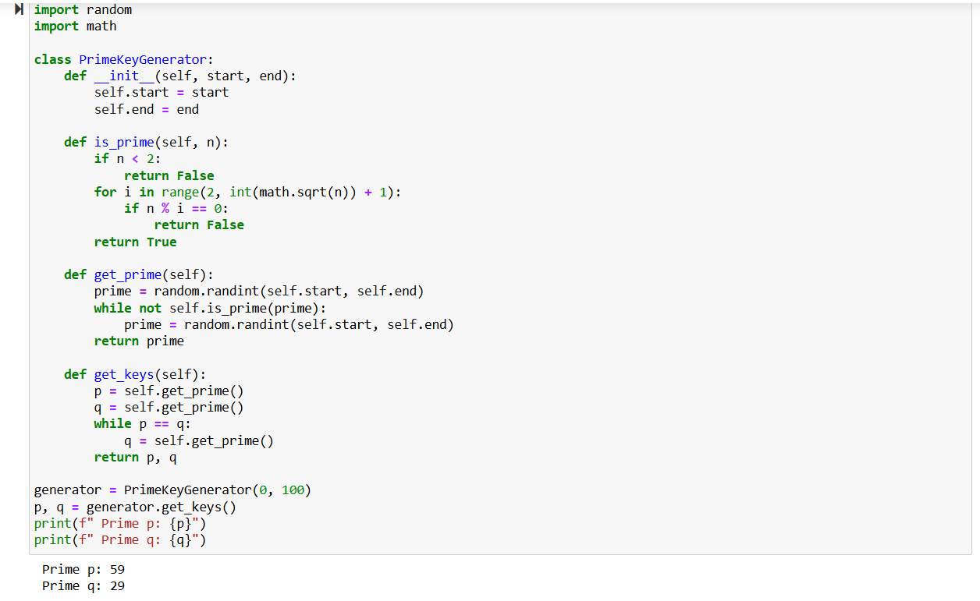

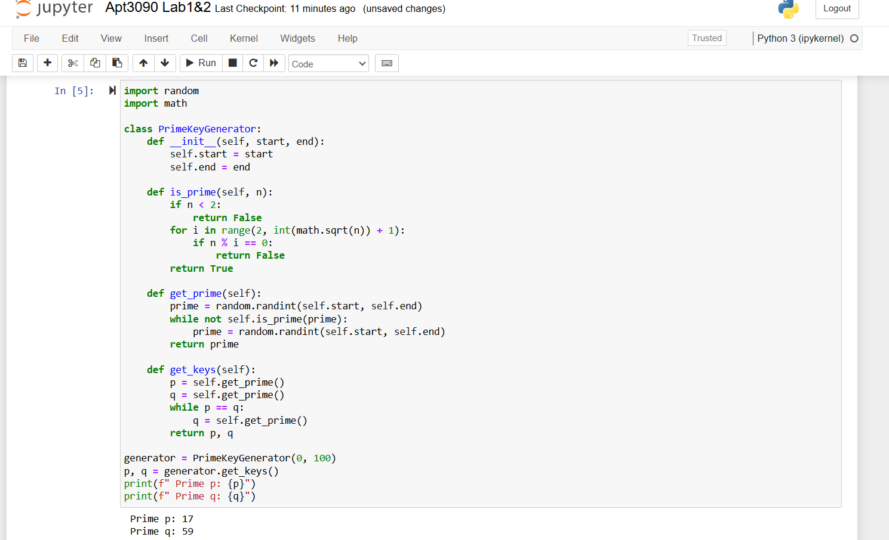

In Lab1, we generate two random prime numbers, p and q, within a given range. We use trial division up to the square root of the number to check if a number is prime. Finally, we make sure that p and q are distinct primes.